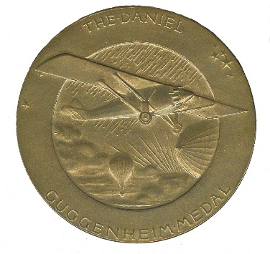

Daniel Guggenheim Medal Award

Nomination Form
Sponsoring Societies:
www.guggenheimmedal.org
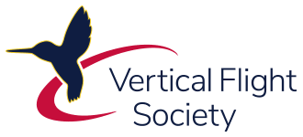

American Institute of Aeronautics and Astronautics (AIAA), American Society of Mechanical Engineers (ASME), SAE International, and the Vertical Flight Society (VFS) are proud to award The Daniel Guggenheim Medal.
The Daniel Guggenheim Medal was established as an international award for the purpose of honoring an individual who makes notable achievements in advancing the safety and practicality of aviation. The Medal recognizes contributions to aeronautical research and education, the development of commercial aircraft and equipment, and the application of aircraft to the economic and social activities of the nation.
To be considered for this award, the nominator must submit the following nomination form, a resume of no more than 5 pages, and a minimum of three to a maximum of five 1-page endorsement letters. The nominator is to submit the complete nomination package to The Guggenheim Medal Administrator at awards@aiaa.org by the deadline of 1 February. This is an annual award.

Self-nominations are not permitted. Guggenheim Board Members cannot act as a nominator or reference to any active Guggenheim nomination. The nominator cannot act as a reference.

The nomination will be considered for a total of three years (the original year plus two subsequent years).

This award will be presented at the annual AIAA Aerospace Spotlight Awards Gala in May in Washington, D.C. or at a venue preferred by the award winner.

Death of the candidate subsequent to selection at the meeting of the Board shall not debar said candidate from posthumous Award if the selection is confirmed in regular course by letter-ballot. Such posthumous Award shall consist of a certificate presented to the members of the Medalist’s family.

For more information, please visit www.guggenheimmedal.org or contact The Daniel Guggenheim Board of Award Administrator, the American Institute of Aeronautics and Astronautics, Patricia A. Carr, AIAA, Senior Manager, Honors and Awards Programs, patriciac@aiaa.org.

Daniel Guggenheim Medal Award

Nomination Form
Sponsoring Societies:
www.guggenheimmedal.org
Nomination Deadline: 1 February
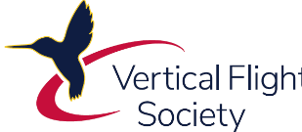

Candidate Information

Date of Submission:

Name
Job Title
Organization
City/State/Zip |  | Country
Telephone |  | Email
Supervisor
Contact Information
Public Relations
Contact Information

Proposed Citation
In 25 words or less, describe specific accomplishments/activities which are the basis for this award

Nominator Information
Self-Nominations are not permitted.
Guggenheim Board Members cannot act as a nominator or reference to any active nomination. Nominator cannot act as a reference.
Include all endorsement letters from the References
Name
Phone Number
Email Address
Signature
Date Submitted

Reference Information

Reference #1: Name
Organization
Email Address

Reference #2: Name
Organization
Email Address

Reference #3: Name
Organization
Email Address

Reference #4: Name (optional)
Organization
Email Address

Reference #5: Name (optional)
Organization
Email Address

BASIS FOR AWARD
On this page only, describe the accomplishments and/or contributions of the nominee which are the basis for this award nomination. Please summarize and/or list specific examples of the candidate’s contributions to advancing the safety and practicality of aviation through aeronautical research and education, the development of commercial aircraft and equipment, and the application of aircraft to the economic and social activities of the nation.

